**DISABILITY WORKING GROUP**

**Key Messages from 17 January 2025 Meeting**

**Easy Read Format**

 **Members**: John Marrable, Kirsten Dixon, Paula Waby, Adam Hall, Jacqui Eggleton, Jaime Randhawa, Adam Hall, Te Aroha Aratangi, Philippa Henderson

**Standing members**: Kathryn Harkin, Isabelle Jenkins

**Apologies**: None



**Changes to Conflict of Interest Register**

* Jackie onto Head Trust Board for CCS Disability Action

**Actions updates:**

* Hidden Disability Sunflower

Staff are continuing to be trained, currently waiting for the security team to complete.

**Guest Speaker**

* Isabelle Jenkins, Well South works in “Health Equity Team” at WellSouth.

WellSouth knows the importance of a focus on disability as they hadn’t done this in the past and have now got their own action plan.

This plan sits under the Health NZ Southern Disability Strategy.

In 2024, a steering group was formed with 7 community members and 4 WellSouth staff.

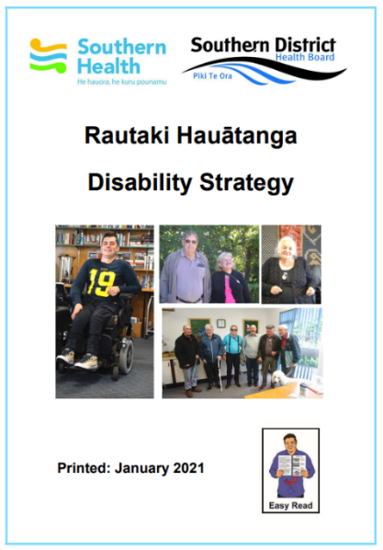

Over mid-2024, talks were held with over 20 community groups including supporters.

They are aware that they didn’t meet with everyone but did have a wide range of engagement tools.

They loosely based this on the three goals in the strategy.

* Key parts of the plan include:

WellSouth will have a role focused to disability in health equity including planning, delivery and looking at different programmes.

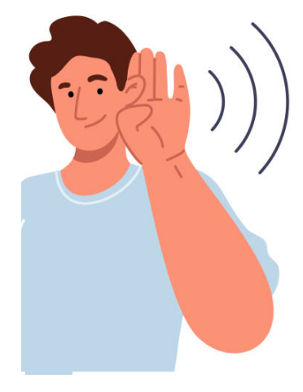

They will focus on listening and responding to community, this was a key issue that came from meetings. They will also involve consumers in the process, as per “Code of Expectations.”

They will aim to improve primary care services – making up a "practice tool kit” for primary care providers including a policy as well as resources for those in doctor practices.



This also includes looking at what already exists and how they can find these. Also want to do an audit of accessibility in general practice, both physical and non physical parts.

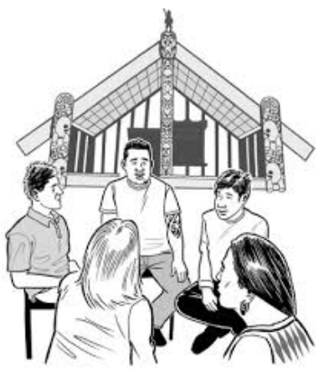Ensuring that WellSouth is an accessible and the right organisation for tangata whaikaha to work at and that there is a hiring process which is fair with equal access to opportunities for all job applicants and that there is training for staff on joining WellSouth.

Audit and accessibility review of their premises as well.

* In December 2024 the Action plan was approved by the Senior Leadership Team of WellSouth.
* Isabelle has joined with 2 other Primary Health Organisation to speak with equity leads who seem to be the only people who are doing focused work in this area.

They have also focussed ensuring that all those they speak to are the first to hear about it.

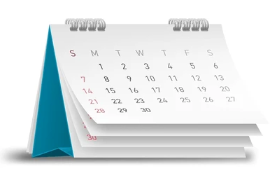 Isabelle has 1 day a week devoted on this work, and Andrew Sise will also be helping the first roll out.

Has been meeting with others and building network and currently working on a framework for the roll out.

* A group of hands giving thumbs up

  Description automatically generatedReflection that the Disability Working group members on the steering group welcome the return of WellSouth to our meeting to update on the plan and felt good about this plan.



**Chairman’s update on talk with regional chairpersons**

* 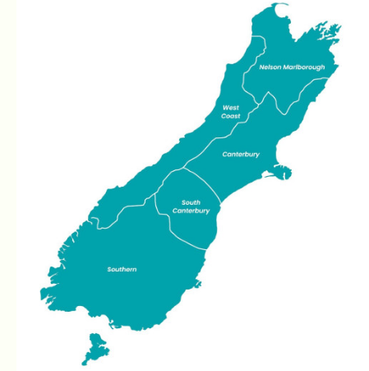John updated the members on a regional meeting held with Kathy O’Neill from Health New Zealand, Te Waipounamu (South Island), Grant Clellan Canterbury Chairperson and Kathryn.

West Coast has a Disability Steering Group, but they weren’t able to attend.

Nelson Marlborough and South Canterbury do not have groups currently.

Accessible health information project being worked on currently with health information being stored in one location with Health NZ in accessible formats.

* Members talked about the difference between mental health and disability – a fine line that can be hard to explain.

* Round Table

Temporary shuttle still running in Waitaki while they wait for St John. The Stronger Waitaki Group still exists, just changing focus.

Your Way Kia Roha success through engaging with businesses in Southland supporting EGL Principles and encouraging employment.

Disabled parks in Oamaru are working well especially as currently very busy.

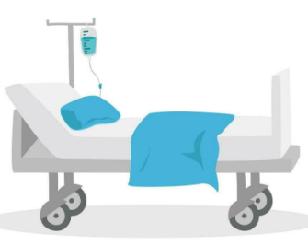

Privacy issue at Oamaru hospital happened with a half-undressed patient not being provided with a cover while in bed.

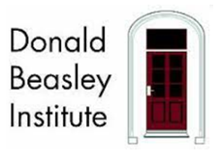

A new Donald Beasley Institute Health Research project has started for people with learning disabilities.

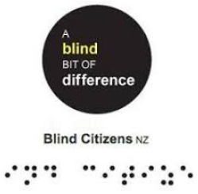Instead of Blind Citizens Network, they are going back to being a branch which means they will have more standing when they go to organisations with specific questions etc.

Now enough interest to have a committee which is very positive.