**DISABILITY WORKING GROUP**

**Key Messages from 15 November 2024 Meeting**



**Members**: John Marrable, Kirsten Dixon, Paula Waby, Adam Hall, Jacqui Eggleton, Jaime Randhawa, Te Aroha Aratangi

**Standing members**: Kathryn Harkin

**Apologies**: Ruth Zeinert, Jack Devereux,

**Guests**: Andrew Cunningham

* **Actions updates**:
* John has spoken to Rochell at Livingwell Disability Resource Centre about giving an old hire wheelchair to the Waitaki Hospital for use.
* Accessibility Audits in Southland currently on hold.
* A different types of natural disasters

  Description automatically generatedAndrew Cunningham, Emergency Management Lead for Te Whatu Ora Southern. Has a counterpart in Southland as well. In peacetime, largely planning and when an event happens, ensure that the most at-risk people are able to be cared for.

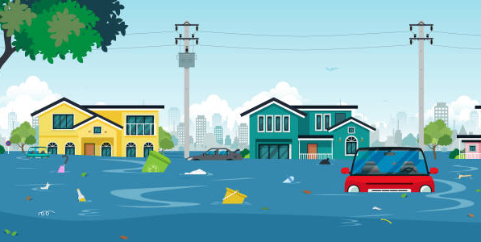Example of flooding, working with other services to ensure that those who may not be able to evacuate where safe.

There has not been a proper plan before to specifically involve the disabled community, but he is very aware how tough it can be to get the right help, so wants to ensure they understand what the needs are.

For Deaf people communicating is one of the biggest issues they have.

In an emergency, mental health for Deaf people is really important, as stress can make it even harder.

For example, how would a Deaf person know who to contact?

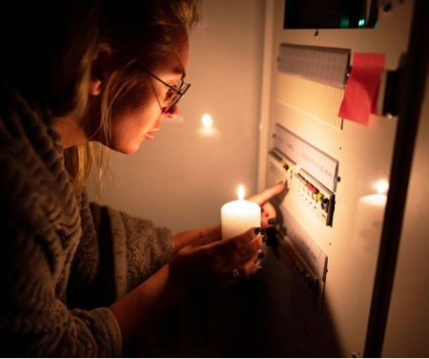

If there is no power, there are no interpreters.

Some education required in Waitaki as well Andrew will link with local planners to engage with Jacqui.

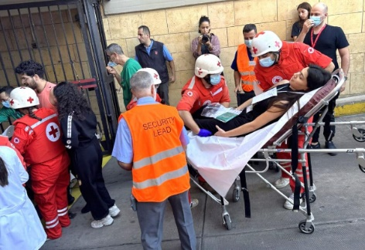

Exercise emergency planned in February, will also include disability into this as well.

* A hand holding a pen over a clipboard

  Description automatically generatedKathryn Harkin presented the results of the most recent “Consumer Engagement Quality Safety Marker”.

This is completed twice yearly by all services in Southern.

The most recent one found that the use of “equity data” has dropped over the last year – this is in line with instructions from the Government.

Work with community organisations by service leaders has also dropped in this time.

One specific question asked:

“Specifically for this service, which population groups have been identified as having poorer health outcomes?”

There was a big increase in services identifying the disabled community as falling into this grouping which was positive.

The following question designed by the Disability Working Group was again asked:

“What is happening within your service to improve equitable access for the disabled community (including those with physical, sensory, intellectual, mental disabilities)?”

There were a range of answers with many services able to give detail on activities which have been undertaken but there were also others who had nothing to report.

Given the pressures on all services currently, the effort is on trying to achieve something realistic and able to be continued over a period of time so that there is continued progress.

* 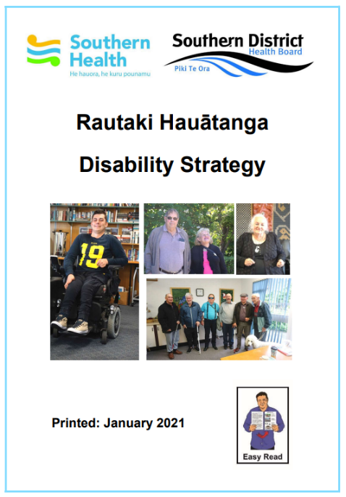A recent review of the Southern Disability Strategy showed that there are two goals which currently do not have linked actions.

These are:

*“Southern will undertake a review of how people access assistance and allowances to develop a straightforward process to enable people to navigate their systems with ease and receive the support available to them”*

and

*“Information systems will track requests for support, structural alterations or equipment both for the purpose of ensuring prompt responses to meet the person’s needs and as auditable data for later evaluation of the Southern Disability Strategy.”*

It was agreed that these were unclear, especially the first, as “assistance and allowances” are not provided by Te Whatu Ora Southern but by other organisations.

The second item is also unclear as many items asked for go to an organisation outside the hospital for action which, with limited funding, means patients are often waiting a long time, and this is not in Te Whatu Ora Southern’s control either.

Members were happy that Kathryn will make a report outlining what is able to be done in this area and this will be taken as actioning this “strategic goal”.

* **A group of people sitting in chairs

  Description automatically generatedRound Table**

A new “Stronger Waitaki Lead” has been appointed. Change project for council currently, all groups being stood up. New appointee has interest in equitable practice with schools – an ideal person to continue the conversation about having an equitable practice.



Kōrero mai posters and information have been seen in Dunedin hospital and very pleased to see this rolled out.

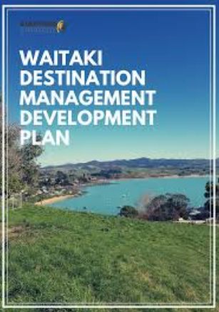

Working on “Waitaki Health Development project” – great response from the community.

Has been noted that physio and OT appointments in Oamaru hard to get if you have a disability. Telehealth does not work for those with communication barriers.

Braille on medicine bottles, required by law in some parts of the world, but not in NZ. Would like to see this happen.

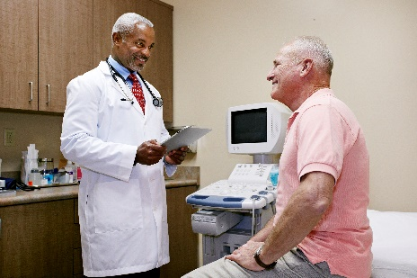

Access to family doctors in Waitaki is still hard, however WellSouth is going to support with this.

Family Doctors also not doing small operations such as ingrown toenail and these are being referred to hospital, to be done by same doctor – this is likely a financial decision.

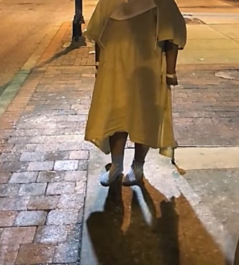

Patient had been discharged from Dunedin Hospital at night – after being transferred from Oamaru, more information to be provided for investigation.

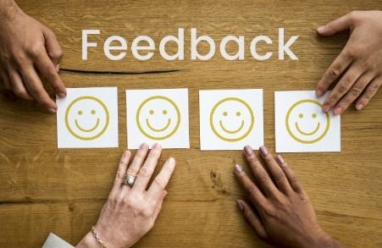

Good feedback from some members of blind community who have reported good experiences at the hospital.



Confusion and noise for Deaf/blind person, makes it hard to understand what was happening.

Strong accents made this hard as well.

Deaf consumer pregnant, talking with services early to make sure they are aware of her needs.