**DISABILITY WORKING GROUP**

**Key Messages September 2024**

**Easy Read Format**

**Members**: John Marrable, Kirsten Dixon, Paula Waby, Adam Hall, Jacqui Eggleton, Te Aroha Aratangi, Jaime Randhawa,

**Standing members**: Kathryn Harkin

**Apologies:** Ruth Zeinert, Jack Devereux,

**Guests:** Sam Murray, Andrew Sise, Alexandra Carr

The Disability Working Group (DWG) members met on Friday 20 September 2024.

* Actions updates:

PayWave proposal - no cost to upgrade keypad and card reader. Finance are looking into the bank fees

More eye health services are hoped to be able to be offered in Waitaki now that they are under Southern



Neurology are looking at providing more “Disease Modifying Therapy” in Oamaru, more information will be provide as available.

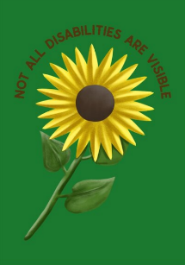 Hidden Disability Sunflower training now available for all staff, key areas of focus are outpatient clinics, Emergency Departments, patient enquiries and security.

Next quarterly forum at end of October

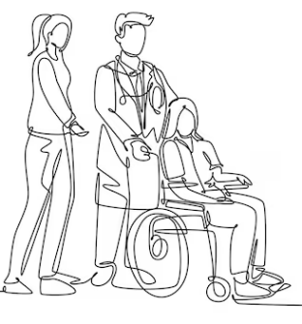

Sam Murray, Policy Advisor, attended the meeting to discuss the draft “Patient Rights, Equity and Cultural Safety Policy”.

We have a current policy but needed to expand this to cover some areas in our compliance with “Nga Paewera” Standards.

The aim was to code our Strategy as it hasn’t been linked to the policy before.. There is a new part about disability in the new policy.

There is currently work in progress to link disability awareness training into the training processes for 3 year training - it is in the most recent part of the Senior Medical Officer training.

Also an opportunity to add into the policy the right to an interpreter - we just have guidelines at the moment.

Aware that the policy is not the strongest form of control - it is better to have other tools in place to effect changes in behaviour.

Also looking into how to give more value to our responsibility to speaking with our patients.

Alexandra Carr, Deaf and Disability Lead for Survivor Experience Services, attended to advise members about the service.

The Survivor Experiences Service is for people who were abused in state, faith-based, or other forms of care.

The Survivor Experiences Service is for:

* 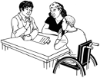people who have experienced abuse while in care
* 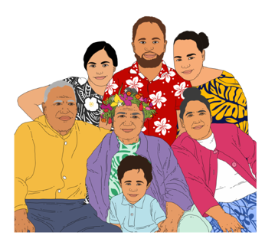people to talk about what happened to them
* people and their whānau / families to get the support they need.

They are holding space between the end of the “Royal Commission of Enquiry into Abuse in Care”, and something more permanent being in place.

Stories can be heard from any time, not just before 1999 (as with the Commission).

The service will work with what is culturally and emotionally required.

Abuse can be:

* 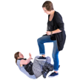**physical** – kicking or hitting you
* 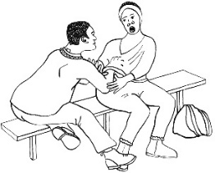**sexual** – doing sexual things to you that you do not want like:
* 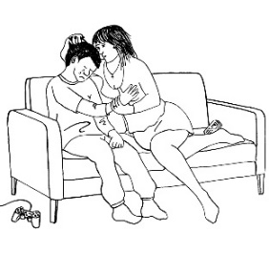touching your body or private parts
* kissing you
* 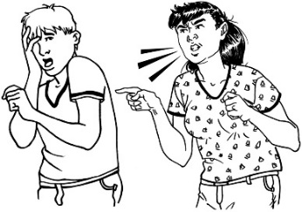making you have sex – this is called rape
* 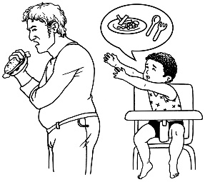**emotional** – yelling or saying things to you that are not nice
* **neglect** – not giving you the things or care you need.



Topics and highlights will be recorded and provided to ministers, which will in turn help to inform the government response.

The other part of the service is supporting people to get access to their own records.

The Commission didn’t hear enough from Māori, Pasifika, Deaf, disabled, and the rainbow community. Alexandra Carr will be in Invercargill from 7-11 October and able to meet with anyone.

Andrew Sise, Well South, attended to update members on work towards their Disability Action Plan.

A steering group was set up of 7 community members, and a core team of 4 WellSouth staff.

They have held over 20 community huis and have met with a wide range of people right across the region, with talks about a wide range of issues.



They have heard about a lot of good experiences and the value of a good provider, who have helped patients to get the care they need.

Key barriers which have been identified include

* how appointments are booked,
* act together with reception staff,
* waiting rooms, and
* incidents in the appointment.



Many people gave examples of communication being in a form that they could not use.

They also felt more training was needed and that providers could work more effectively with other providers.



The Action Plan will be finished in the next fortnight and is the promise to WellSouth having a detailed focus on disability and that they recognise this as the beginning of a journey rather than the end.

It will sit under the Southern Disability Strategy.

Key areas of the plan are:

* Meeting the needs of tangata whaikaha Deaf and having full time equivalent employer within WellSouth for this work.
* Continue with meetings with the community
* Supporting primary care to do better
* How WellSouth can do better as an organisation, including managing staff, programmes and working with the public

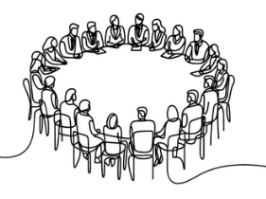**Round Table**

Food parcels in Waitaki have doubled this winter - this has been the need for people to spend money travelling to Dunedin Hospital

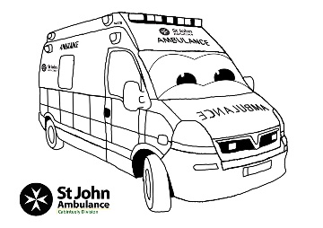St John study to have a shuttle is complete and has shown that Oamaru does needs a shuttle - it will cost around $120,000 to get this in place

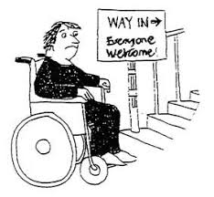

Access into some medical centres is a problem - two have ramps in poor condition, and a room being used for doctors in Omarama is not wheelchair accessible.

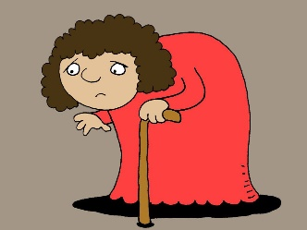

In Oamaru a lady had been advised to walk around to the Emergency Department as no wheelchair was available.

“Equity conversation” at Stronger Waitaki is on hold - there is a big transformation of this programme underway and possibly a change in direction.

A mother travelling on the St John health shuttle was declined service as her baby was coughing - this left her with no transport.

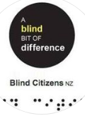

Blind Citizens really pleased being able to provide feedback to WellSouth.

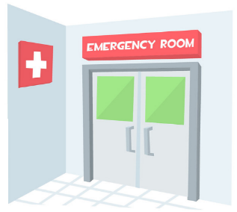Invercargill Emergency Department has recently not provided access to NZSL.

Free teaching has been provided recently; however, more is required.

Talks are continuing with “Consumer Liaison” visiting them next week.

Talks also being put in place between members and the local council around access, mainly in an emergency.